vimrc airline style ... sans airline
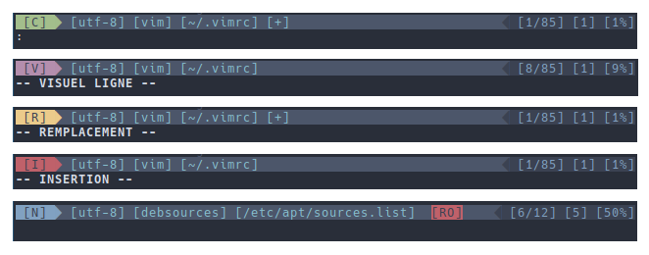
" vim-plug ---
call plug#begin(has('nvim') ? stdpath('data') . '/plugged' : '~/.vim/plugged')
Plug 'preservim/nerdtree'
Plug 'airblade/vim-gitgutter'
Plug 'mhinz/vim-startify'
call plug#end()
" plugins config ---
let g:gitgutter_highlight_lines = 1
let g:gitgutter_highlight_linenrs = 1
" common config ---
colorscheme nord " theme de couleurs
set nocompatible " activation de la conf vim
set autochdir " cd dans le répertoire du fichier
set mouse=a " souris active
set autoread " surveiller les changements du fichier ouvert
set showmode " afficher le mode sur la dernière ligne
syntax on " coloration syntaxique
set number " numérotation des lignes
set cursorline " surligner la ligne active
"set cursorlineopt=number " seulement le numéro de ligne
set ruler " affiche la position du curseur
set hlsearch " surligne les recherches
set ignorecase " ignore la casse lors d'une recherche
set smartcase " sauf si la recherche comporte une majuscule
set preserveindent " preserver l'identation
set autoindent " identation automatique
set shiftwidth=4 " largeur de l'auto-identation
set tabstop=4 " largeur d'une tabulation
set expandtab " remplace les tabulation en espaces
filetype on " détection des fichiers
filetype plugin on " activer les plugins spécifiques
filetype indent on " activer l'identation spécifique
set list " afficher les fins de lignes
set list listchars=nbsp:␣,tab:··,trail:¤,extends:▶,precedes:◀ ",eol:¤
set wildmenu " autocompletion des commandes avec TAB
set wildoptions=pum " popup menu
" Statusline
" %F – Display the full path of the current file.
" %M – Modified flag shows if file is unsaved.
" %Y – Type of file in the buffer.
" %{&fenc} - file encoding.
" %R – Displays the read-only flag.
" %b – Shows the ASCII/Unicode character under cursor.
" 0x%B – Shows the hexadecimal character under cursor.
" %l/%L – Display the line number/total line number.
" %c – Display the column number.
" %p%% – Show the cursor percentage from the top of the file.
" statusline colors
hi NColor ctermbg=4 ctermfg=0
hi NSColor ctermbg=8 ctermfg=4
hi IColor ctermbg=1 ctermfg=0
hi ISColor ctermbg=8 ctermfg=1
hi RColor ctermbg=11 ctermfg=0
hi RSColor ctermbg=8 ctermfg=11
hi VColor ctermbg=5 ctermfg=0
hi VSColor ctermbg=8 ctermfg=5
hi CColor ctermbg=2 ctermfg=0
hi CSColor ctermbg=8 ctermfg=2
hi RightColor ctermbg=0 ctermfg=4
hi RightSepColor ctermbg=8 ctermfg=0
set laststatus=2 " toujours afficher la Statusline
set statusline= " nettoyer la statusline au lancement
" status mode indicator airline style -- demande 'colorscheme nord'
set statusline+=%#NColor#%{(mode()=='n')?'\ \ [N]\ ':''}\%#NSColor#%{(mode()=='n')?'\\':''}
set statusline+=%#IColor#%{(mode()=='i')?'\ \ [I]\ ':''}\%#ISColor#%{(mode()=='i')?'\\':''}
set statusline+=%#RColor#%{(mode()=='R')?'\ \ [R]\ ':''}\%#RSColor#%{(mode()=='R')?'\\':''}
set statusline+=%#VColor#%{(mode()=='v')?'\ \ [V]\ ':''}\%#VSColor#%{(mode()=='v')?'\\':''}
set statusline+=%#CColor#%{(mode()=='c')?'\ \ [C]\ ':''}\%#CSColor#%{(mode()=='c')?'\\':''}
set statusline+=%#StatusLine# " back 2 default
set statusline+=\ [%{&fenc}]\ %y\ [%1.25F]\ %m " status left
set statusline+=\ %#IColor#%r\%#StatusLine# " red bg 4 RO
set statusline+=%=%#RightSepColor#\%#RightColor# " status right
set statusline+=\ [%l/%L]\ [%c]\ [%p%%]

