conky bigbox
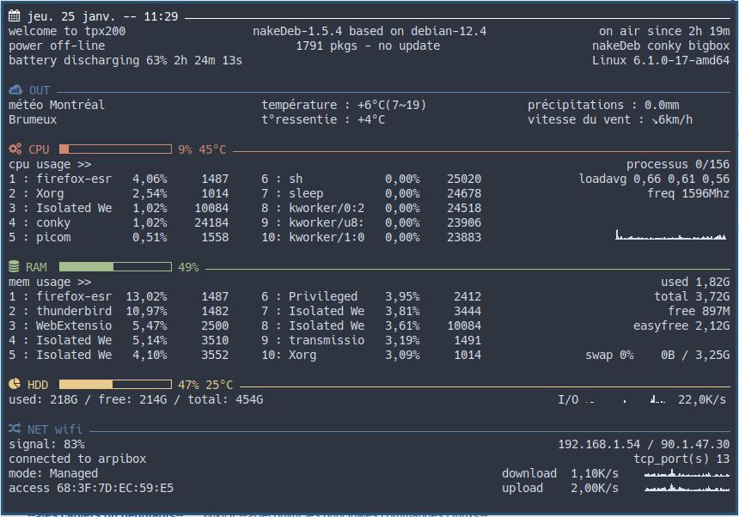
--[[
conky_bigbox
]]
conky.config = {
background = true,
use_xft = true,
font = 'Hack:pixelsize=14',
xftalpha = 1,
update_interval = 1.0,
total_run_times = 0,
own_window = true,
own_window_transparent = false,
own_window_colour = '2e3440',
own_window_type = 'normal',
own_window_hints = 'sticky',
own_window_class = 'conky',
own_window_title = 'Infos System',
own_window_argb_visual = false,
double_buffer = true,
maximum_width = 840,
minimum_width = 840,
minimum_height = 500,
draw_shades = false,
draw_outline = false,
draw_borders = false,
border_inner_margin = 5,
border_width = 0,
draw_graph_borders = false,
default_color = 'd8dee9', --clear
color1 = 'ffffff', --white
color2 = 'ebcb8b', --yellow
color3 = 'a3be8c', --green
color4 = 'd08770', --orange
color5 = 'bf616a', --red
color6 = '5e81ac', --blue
color7 = 'b48ead', --purple
default_shade_color = 'black',
default_outline_color = 'white',
alignment = 'mm',
gap_x = 0,
gap_y = 0,
no_buffers = true,
uppercase = false,
text_buffer_size = 1024,
top_name_width = 10,
imlib_cache_size = 0,
cpu_avg_samples = 2,
show_graph_scale = false,
show_graph_range = false,
short_units = true,
override_utf8_locale = true,
use_spacer = 'none',
if_up_strictness = 'address'
}
conky.text = [[
${color1}${font forkawesome:pixelsize=14}${font} ${time %a %d %b -- %I:%M} ${hr 1}$color
welcome to ${nodename}${goto 290}nakeDeb-${texeci 3600 cat /etc/nakedeb_version} based on debian-${texeci 3600 cat /etc/debian_version}$alignr on air since ${uptime_short}
power ${acpiacadapter} ${goto 340}${texeci 3600 dpkg -l | wc -l} pkgs - ${texeci 3600 nakedupdate -c} $alignr nakeDeb conky bigbox
battery ${if_existing /sys/class/power_supply/BAT0}${battery BAT0} ${battery_time BAT0}${else}${if_existing /sys/class/power_supply/BAT1}${battery BAT1} ${battery_time BAT1}${endif}${endif}$alignr ${sysname} ${kernel}
${if_gw}
${color6}${font forkawesome:pixelsize=14}${font} OUT ${hr 1}$color
météo Montréal${goto 300}température : ${curl wttr.in/~montréal+france?format=%t 30}\
(${texeci 3600 curl -s wttr.in/~montréal+france?format=p1 | grep 'us_min.*0d' | awk '{print $2}'}\
~${texeci 3600 curl -s wttr.in/~montréal+france?format=p1 | grep 'us_max.*0d' | awk '{print $2}'})\
${goto 610}précipitations : ${curl wttr.in/~montréal+france?format=%p 30}
${curl wttr.in/~montréal+france?format=%C+&lang=fr 30}\
${goto 300}t°ressentie : ${curl wttr.in/~montréal+france?format=%f 30}\
${goto 610}vitesse du vent : ${curl wttr.in/~montréal+france?format=%w 30}
$endif
${color4}${font forkawesome:pixelsize=14}${font} CPU${goto 65}${cpubar 10,130} ${cpu cpu0}% \
${ibm_temps 0}°C ${hr 1}$color
cpu usage >> ${alignr}processus ${running_processes}/${processes}
1 : ${top name 1} ${top cpu 1}% ${top pid 1} \
${goto 300}6 : ${top name 6} ${top cpu 6}% ${top pid 6} \
${alignr}loadavg ${loadavg}
2 : ${top name 2} ${top cpu 2}% ${top pid 2} \
${goto 300}7 : ${top name 7} ${top cpu 7}% ${top pid 7} \
${alignr}freq ${freq cpu0}Mhz
3 : ${top name 3} ${top cpu 3}% ${top pid 3} \
${goto 300}8 : ${top name 8} ${top cpu 8}% ${top pid 8}
4 : ${top name 4} ${top cpu 4}% ${top pid 4} \
${goto 300}9 : ${top name 9} ${top cpu 9}% ${top pid 9}
5 : ${top name 5} ${top cpu 5}% ${top pid 5} \
${goto 300}10: ${top name 10} ${top cpu 10}% ${top pid 10} \
${voffset -15}${alignr 5}${cpugraph 20,200}
${voffset -5}${color3}${font forkawesome:pixelsize=14}${font} RAM${goto 65}${membar 10,130} ${memperc}% ${hr 1}$color
mem usage >> $alignr used ${mem}
1 : ${top_mem name 1} ${top_mem mem 1}% ${top_mem pid 1} \
${goto 300}6 : ${top_mem name 6} ${top_mem mem 6}% ${top_mem pid 6} \
$alignr total ${memmax}
2 : ${top_mem name 2} ${top_mem mem 2}% ${top_mem pid 2} \
${goto 300}7 : ${top_mem name 7} ${top_mem mem 7}% ${top_mem pid 7} \
$alignr free ${memfree}
3 : ${top_mem name 3} ${top_mem mem 3}% ${top_mem pid 3} \
${goto 300}8 : ${top_mem name 8} ${top_mem mem 8}% ${top_mem pid 8} \
$alignr easyfree ${memeasyfree}
4 : ${top_mem name 4} ${top_mem mem 4}% ${top_mem pid 4} \
${goto 300}9 : ${top_mem name 9} ${top_mem mem 9}% ${top_mem pid 9}
5 : ${top_mem name 5} ${top_mem mem 5}% ${top_mem pid 5} \
${goto 300}10: ${top_mem name 10} ${top_mem mem 10}% ${top_mem pid 10} \
$alignr swap ${swapperc}% ${swap} / ${swapmax}
${color2}${font forkawesome:pixelsize=14}${font} HDD${goto 65}${fs_bar 10,130 /} ${fs_used_perc /}% \
${ibm_temps 6}°C ${hr 1}$color
used: ${fs_used /} / free: ${fs_free /} / total: ${fs_size /}\
${alignr 5}I/O ${diskiograph 10,100} ${diskio}/s
${if_running mocp}
${color7}${font forkawesome:pixelsize=14}${font} ZIK ${hr 1}$color
${alignc}${texeci 2 mocp-infos}
${endif}
${color6}${font forkawesome:pixelsize=14}${font} NET ${if_up enp0s25}wired ${hr 1}$color
download ${goto 70}${downspeedgraph enp0s25 10,100} ${downspeed enp0s25}/s $alignr ${addr enp0s25} / ${texeci 1200 wget -q -O - checkip.dyndns.org | sed -e 's/[^[:digit:]\|.]//g'}
upload ${goto 70}${upspeedgraph enp0s25 10,100} ${upspeed enp0s25}/s $alignr tcp_port(s) ${tcp_portmon 1 65535 count}${else}${if_up wls1}wifi ${hr 1}$color
signal: ${wireless_link_qual_perc wls1}% $alignr ${addr wls1} / ${texeci 1200 wget -q -O - checkip.dyndns.org | sed -e 's/[^[:digit:]\|.]//g'}
connected to ${wireless_essid wls1} $alignr tcp_port(s) ${tcp_portmon 1 65535 count}
mode: ${wireless_mode wls1} ${goto 580}download ${goto 660}${downspeed wls1}/s ${alignr}${downspeedgraph wls1 10,100}
access ${wireless_ap wls1} ${goto 580}upload ${goto 660}${upspeed wls1}/s ${alignr}${upspeedgraph wls1 10,100}${else} ${hr 1}$color
$alignr no network$endif$endif
]]

