conky tree
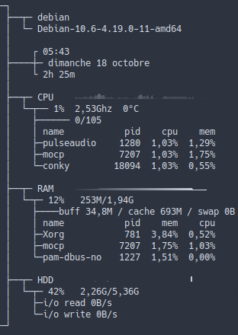
--[[
conky_tree
char : ─ │ ┌ ┐ └ ┘ ├ ┤ ┬ ┴ ┼
set own_window_type from 'desktop' to 'override' to use in i3wm
]]
conky.config = {
background = true,
use_xft = true,
font = 'Hack:pixelsize=12',
xftalpha = 1,
update_interval = 1.0,
total_run_times = 0,
own_window = true,
own_window_transparent = true,
own_window_type = 'desktop',
own_window_hints = 'undecorated,below,sticky,skip_taskbar,skip_pager',
own_window_class = 'conky',
own_window_title = 'conky_tree',
own_window_argb_visual = false,
double_buffer = true,
draw_shades = false,
draw_outline = false,
draw_borders = false,
border_inner_margin = 0,
border_width = 0,
draw_graph_borders = false,
alignment = 'tl',
gap_x = 0,
gap_y = 0,
no_buffers = true,
uppercase = false,
text_buffer_size = 1024,
top_name_width = 10,
imlib_cache_size = 0,
cpu_avg_samples = 2,
show_graph_scale = false,
show_graph_range = false,
short_units = true,
override_utf8_locale = true,
use_spacer = 'none',
if_up_strictness = 'address',
default_color = 'd8dee9',
default_shade_color = 'black',
default_outline_color = 'white'
}
conky.text = [[
─┐
├──┬─ ${nodename}
│ ├─ Debian-${texeci 28800 cat /etc/debian_version}-${kernel}
│ └─ ${texeci 600 nakedupdate -c}
│
│ ┌ ${time %I:%M}
├────┼─ ${time %A %d %B}
│ └ ${uptime_short}
│
├──┬─ CPU ${cpugraph 8,180 2E3440 D8DEE9 -l -t}
│ └─┬── ${cpu}% ${freq_g}Ghz ${acpitemp}°C
│ ├────── $running_processes/$processes
│ │ name${goto 150} pid cpu mem
│ ├─${top name 1}${goto 150}${top pid 1}${top cpu 1}%${top mem 1}%
│ ├─${top name 2}${goto 150}${top pid 2}${top cpu 2}%${top mem 2}%
│ └─${top name 3}${goto 150}${top pid 3}${top cpu 3}%${top mem 3}%
│
├──┬─ RAM ${memgraph 8,180 2E3440 D8DEE9 -l}
│ └─┬─ ${memperc}% ${mem}/${memmax}
│ ├────buff ${buffers} / cache ${cached} / swap ${swap}
│ │ name${goto 150} pid mem cpu
│ ├─${top_mem name 1}${goto 150}${top_mem pid 1}${top_mem mem 1}%${top_mem cpu 1}%
│ ├─${top_mem name 2}${goto 150}${top_mem pid 2}${top_mem mem 2}%${top_mem cpu 2}%
│ └─${top_mem name 3}${goto 150}${top_mem pid 3}${top_mem mem 3}%${top_mem cpu 3}%
│
├──┬─ HDD ${diskiograph 8,180 2E3440 D8DEE9}
│ └─┬─ ${fs_used_perc /}% ${fs_used /}/${fs_size /}
│ ├─i/o read ${diskio_read}${color}/s
│ └─i/o write ${diskio_write}${color}/s
─┘
]]

